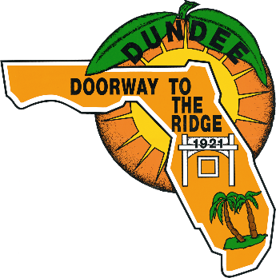
AGENDA
TOWN OF DUNDEE, FLORIDA
TOWN COMMISSION MEETING
JULY 14, 2020
6:30 P.M.

COMMISSION CHAMBERS
202 E. Main Street, Dundee, FL 33838
Phone: 863-438-8330
www.townofdundee.com

CALL TO ORDER: MAYOR PENNANT
PLEDGE OF ALLEGIANCE: MAYOR PENNANT
INVOCATION: TO BE ANNOUNCED
RECOGNITION OF SERGEANT AT ARMS: SGT. TANNER
ORDINANCE #13-08, PUBLIC SPEAKING INSTRUCTIONS: MAYOR PENNANT
ROLL CALL: JENN GARCIA

DELEGATIONS-QUESTIONS & COMMENTS FROM THE FLOOR
(Each speaker shall be limited to three (3) minutes)

APPROVAL OF CONSENT AGENDA: CONSENT AGENDA FOR JULY 14, 2020

CONSENT AGENDA
TAB 1: COMMISSION CONSENT AGENDA
- TOWN COMMISSION MINUTES
- REGULAR MEETING- 06/23/2020
- RESIGNATIONS
- TREE BOARD- AMY BIGGAR
- REAPPOINTMENTS
- PLANNING & ZONING COMMITTEE- SAM AHMED

APPROVAL OF AGENDA: AGENDA FOR JULY 14, 2020

AGENDA
TAB 2: RESOLUTION NO. 20-17: CSP FOR VISTA DEL LAGO PHASE III
TAB 3: DISCUSSION: ROYAL OAKS MOBILE HOME PARK
TAB 4: RESOLUTION NO. 20-15: STATE ROADWAY, LIGHTING SYSTEM MAINTENANCE
TAB 5: RESOLUTION NO. 20-16: PROPOSED MILLAGE RATE
TAB 6: ORDINANCE NO. 20-06: FIRST READING- CROW
TAB 7: DISCUSSION AND ACTION: VISTA DEL LAGO II- ERC RENEWAL
TAB 8: DISCUSSION AND ACTION: EQUIPMENT AUCTION AUTHORIZATION
TAB 9: DISCUSSION AND ACTION: TOWN MANAGER SEARCH COMMITTEE
TAB 10: DISCUSSION AND ACTION: INTERIM TOWN MANAGER

REPORTS FROM OFFICERS
- TOWN ATTORNEY
- TOWN MANAGER
- COMMISSIONERS
- MAYOR
ADJOURNMENT

PUBLIC NOTICE
PLEASE BE ADVISED THAT IF YOU DESIRE TO APPEAL FROM ANY DECISIONS MADE AS A RESULT OF THE ABOVE HEARING OR MEETING, YOU WILL NEED A RECORD OF THE PROCEEDINGS AND IN SOME CASES, A VERBATIM RECORD IS REQUIRED. YOU MUST MAKE YOUR OWN ARRANGEMENTS TO PRODUCE THIS RECORD. (FLORIDA STATUTE 286.0105)

IF YOU ARE A PERSON WITH DISABLITY WHO NEEDS ANY ACCOMODATIONS IN ORDER TO PARTICIPATE IN THIS PROCEEDING, YOU ARE ENTITLED, AT NO COST TO YOU, TO THE PROVISION OF CERTAIN ASSISTANCE. PLEASE CONTACT THE TOWN CLERK’S OFFICE AT 202 EAST MAIN STREET, DUNDEE, FLORIDA 33838 OR PHONE (863) 438-8330 WITHIN 2 WORKING DAYS OF YOUR RECEIPT OF THIS MEETING NOTIFICATION; IF YOU ARE HEARING OR VOICE IMPAIRED, CALL 1-800-955-8771.

