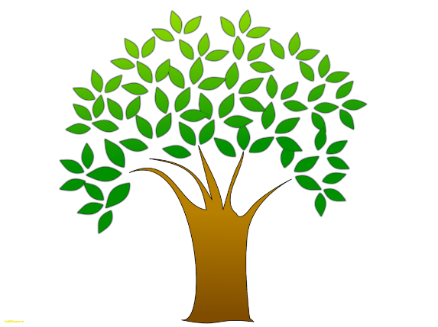

CELEBRATE ARBOR DAY! Drive-up Event
Saturday, April 10, 2021 from 9:00am – 1:00pm

Adults & Children will receive
FREE Seed Packets & Educational Information
TO BEAUTIFY YOUR HOME & DUNDEE

Receive your FREE GIFT at the Following Locations:
Henderson Park - 413 Martin Luther King Street
Dundee Community Center - 603 Lake Marie Blvd.
Dundee Town Hall Parking Lot - 202 E. Main Street

SHOW EVERYONE HOW YOUR FAMILY MADE #DundeeBeautiful
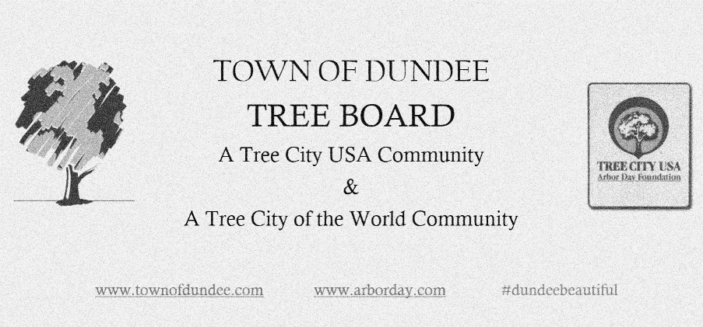
SPONSORED BY THE DUNDEE TREE BOARD

