RESOLUTION 21-31
A RESOLUTION OF THE TOWN OF DUNDEE, POLK COUNTY, FLORIDA, AMENDING FINAL APPROPRIATION OF FUNDS FOR THE FISCAL YEAR 2020 – 2021 BUDGET; PROVIDING FOR AN EFFECTIVE DATE.
WHEREAS, revenue and expenditure estimates are made prior to the beginning of each fiscal year, and
WHEREAS, events occur during each fiscal year which were not anticipated by the original estimates, and
WHEREAS, a change in circumstances regarding projected revenue and expenditures occurred making it appropriate to amend the Fiscal Year 2020 – 2021 budget, and
WHEREAS, each fund budget shall not exceed their appropriation per Florida Statute 166.241:
NOW, THEREFORE, BE IT RESOLVED by the Town of Dundee, Polk County, Florida, that:
- That the budget for the Fiscal Year 2020 - 2021 of the Town of Dundee is hereby amended as detailed on Exhibit “A” as attached hereto.
INTRODUCED AND PASSED by the Town Commission of the Town of Dundee, Florida, in regular session, this 30th day of November 2021.

TOWN OF DUNDEE
_________________________
Sam Pennant, Mayor
CLERKS ATTESTMENT:
TOWN SEAL
_____________________________
Jenn Garcia, Town Clerk

APPROVED AS TO FORM:

____________________________
Town Attorney
EXHIBIT A
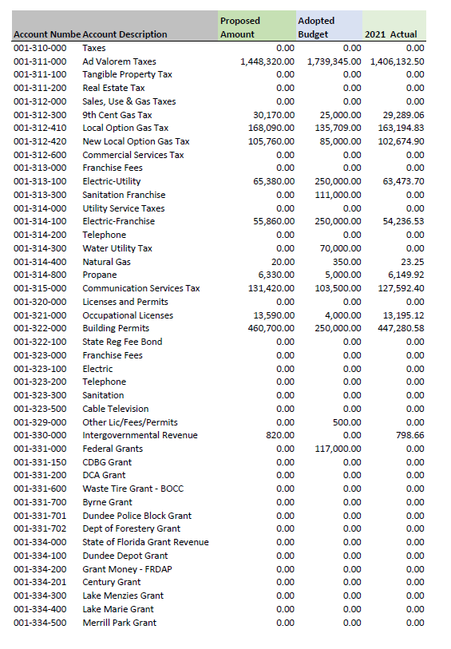
EXHIBIT A
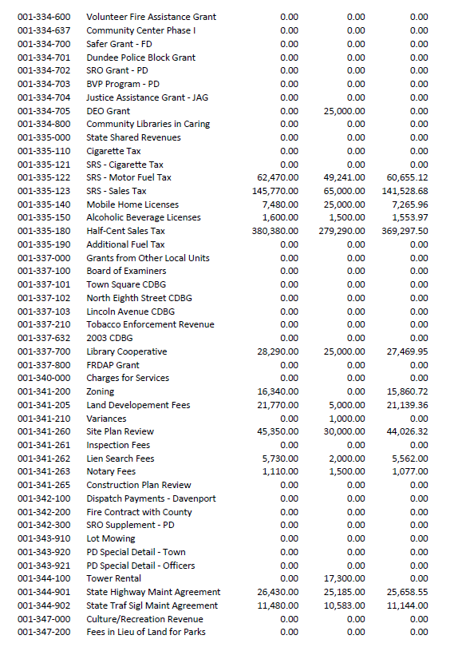
EXHIBIT A
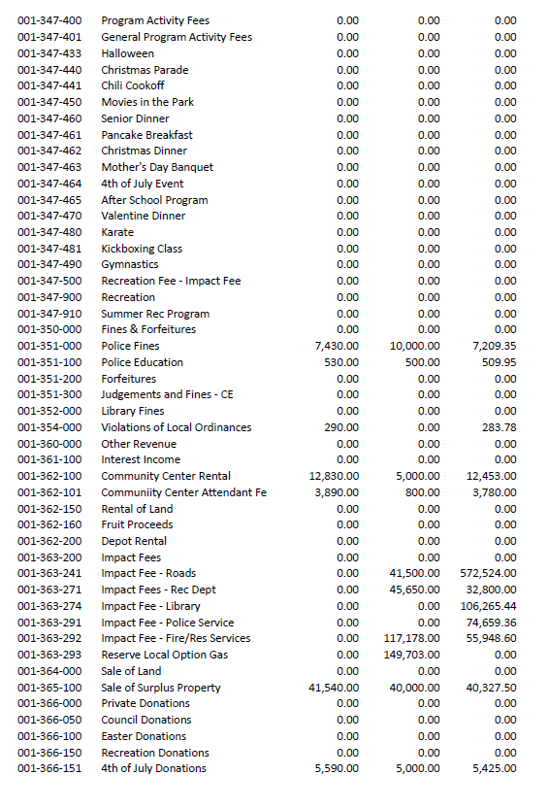
EXHIBIT A
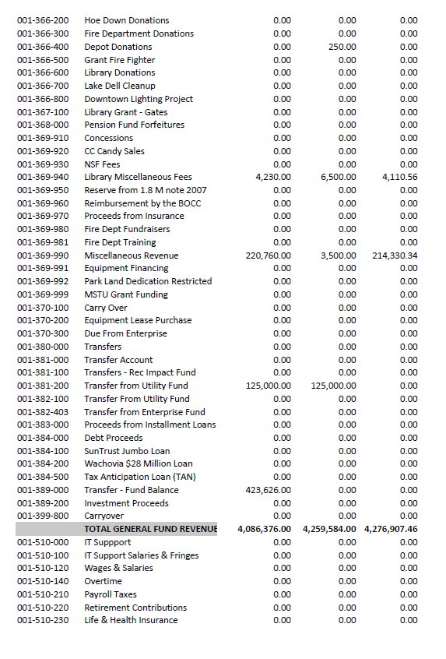
EXHIBIT A
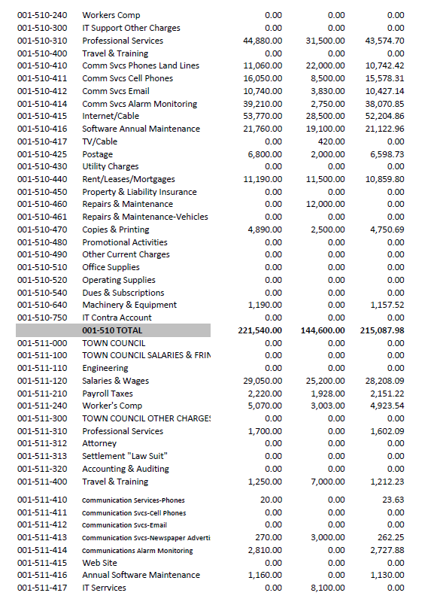
EXHIBIT A
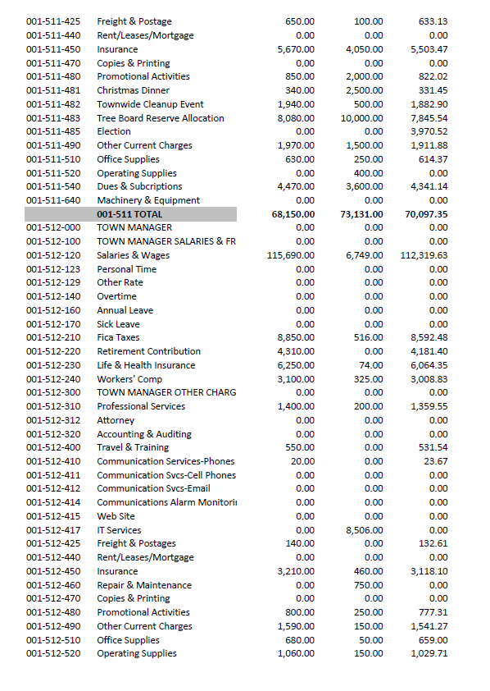
EXHIBIT A
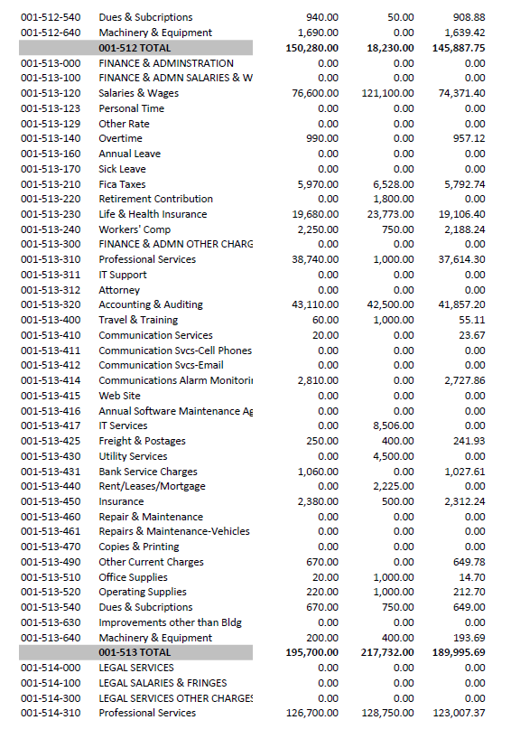
EXHIBIT A
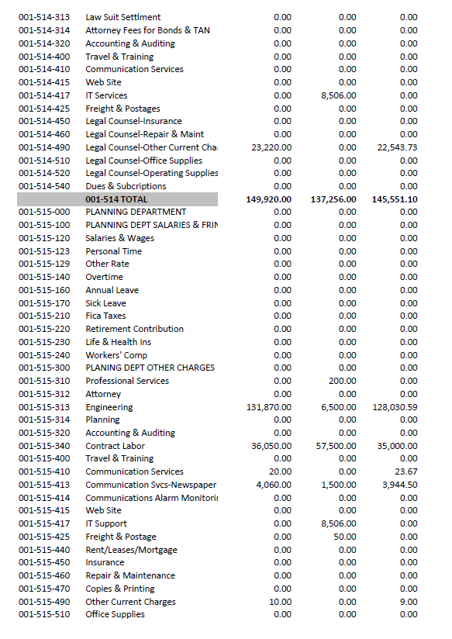
EXHIBIT A
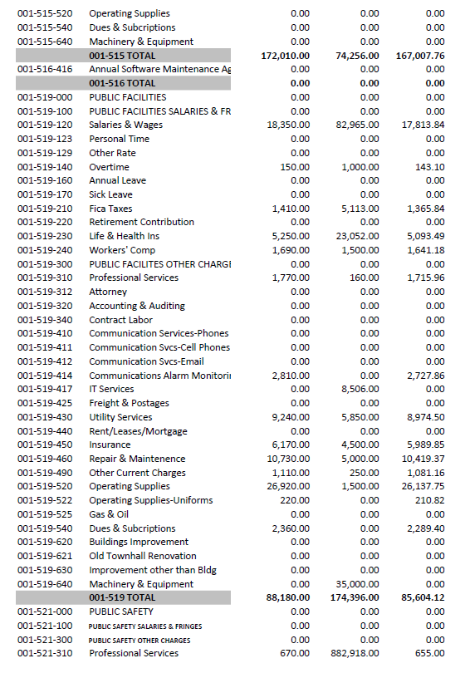
EXHIBIT A
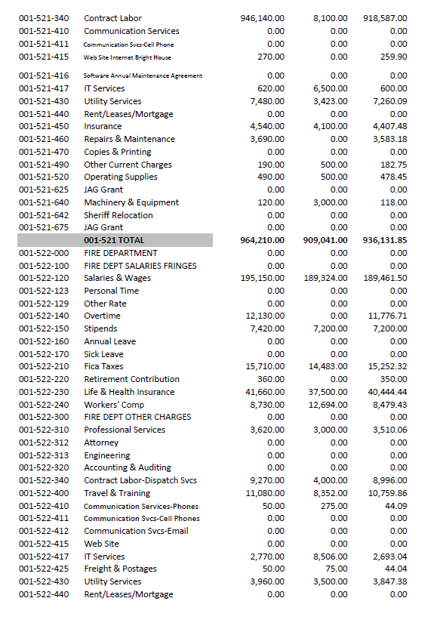
EXHIBIT A
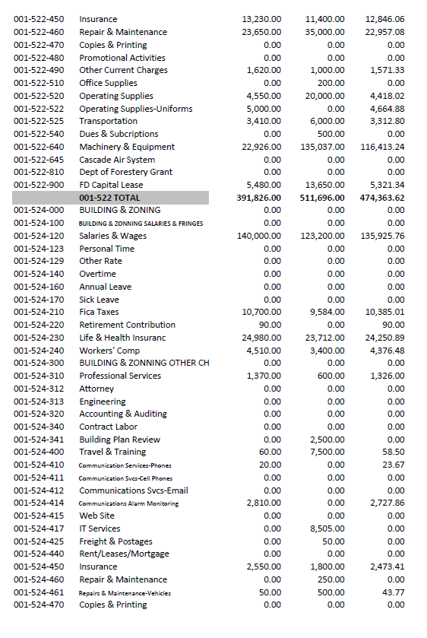
EXHIBIT A
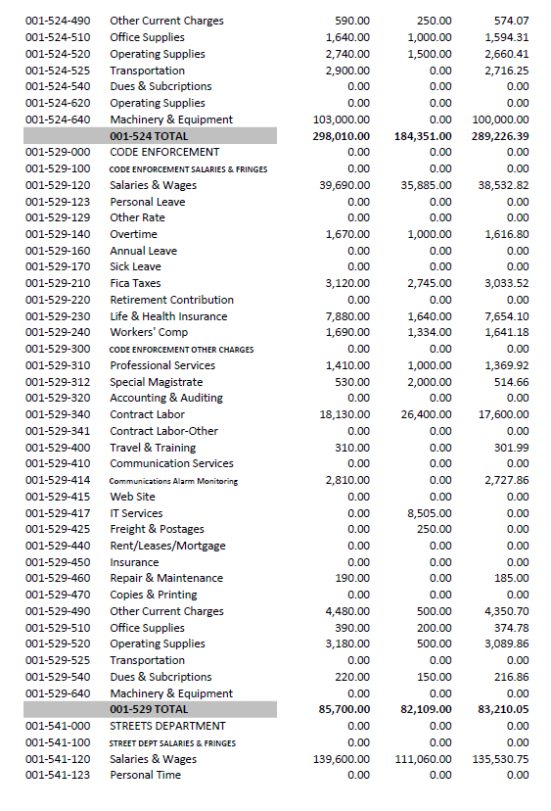
EXHIBIT A
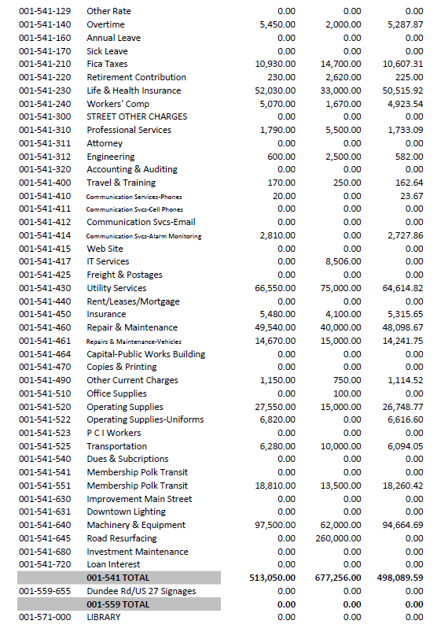
EXHIBIT A
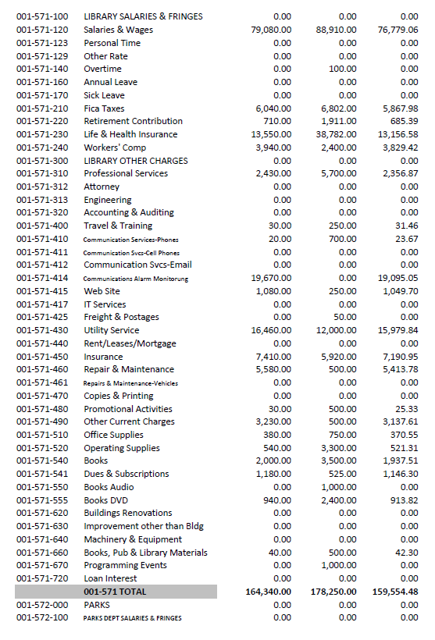
EXHIBIT A
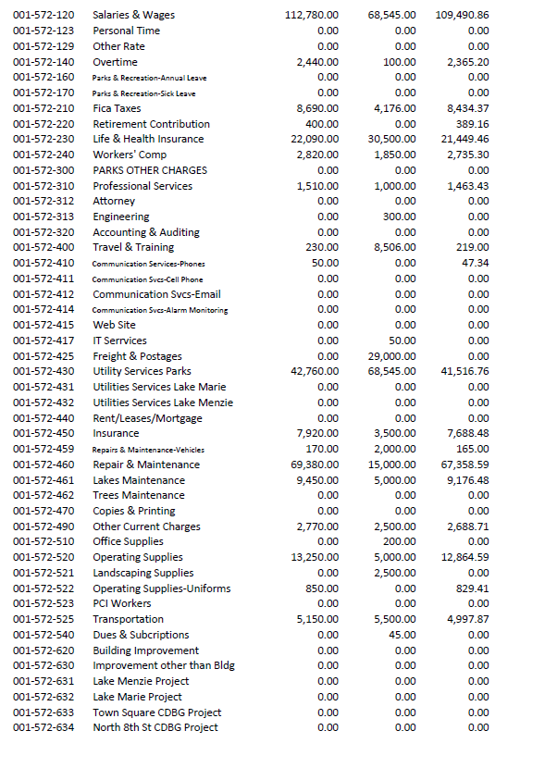
EXHIBIT A
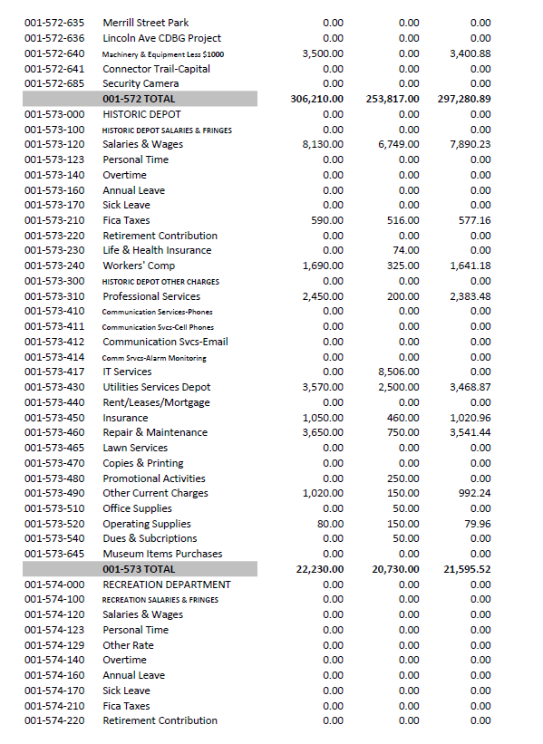
EXHIBIT A
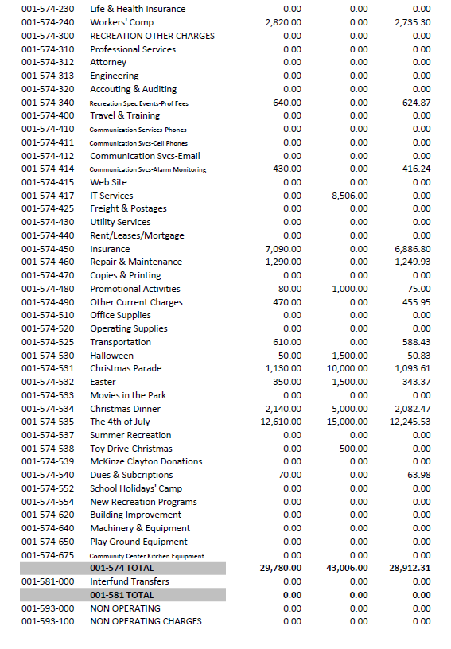
EXHIBIT A
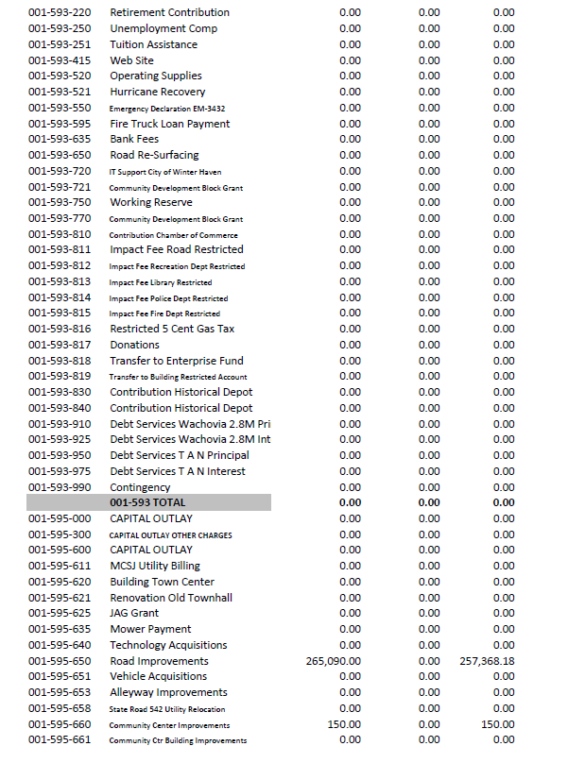
EXHIBIT A
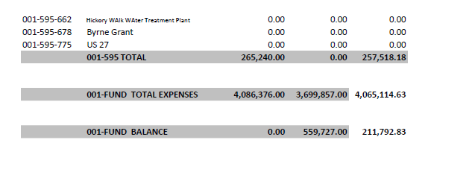
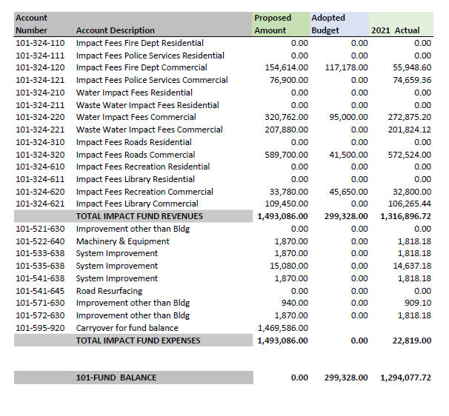

EXHIBIT A
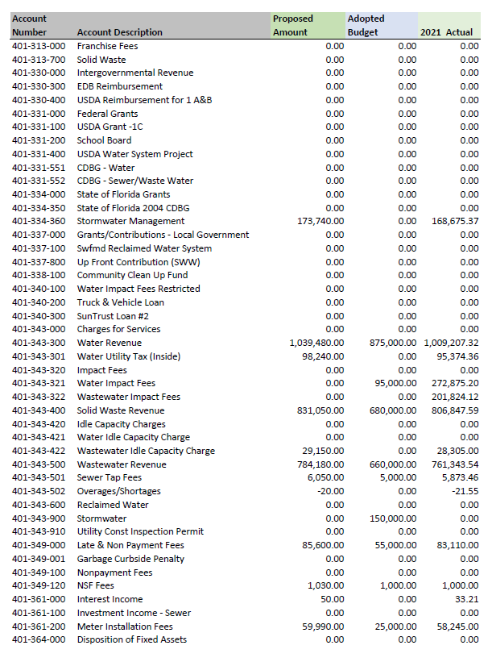
EXHIBIT A
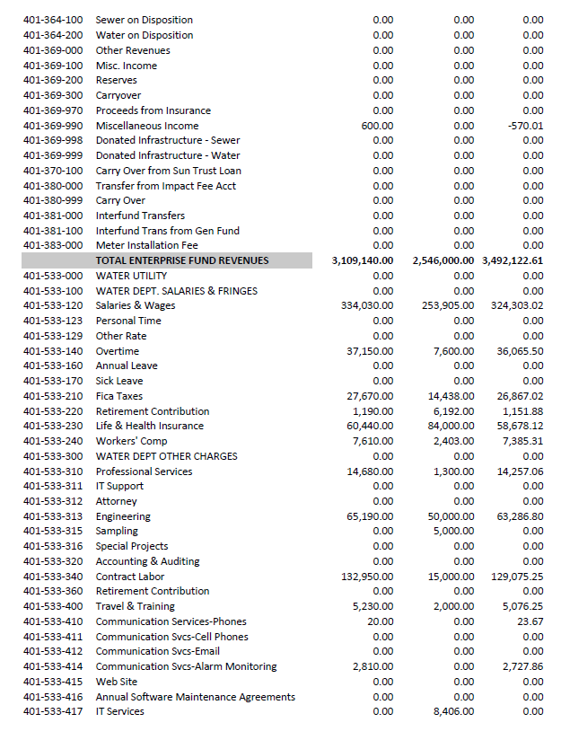
EXHIBIT A
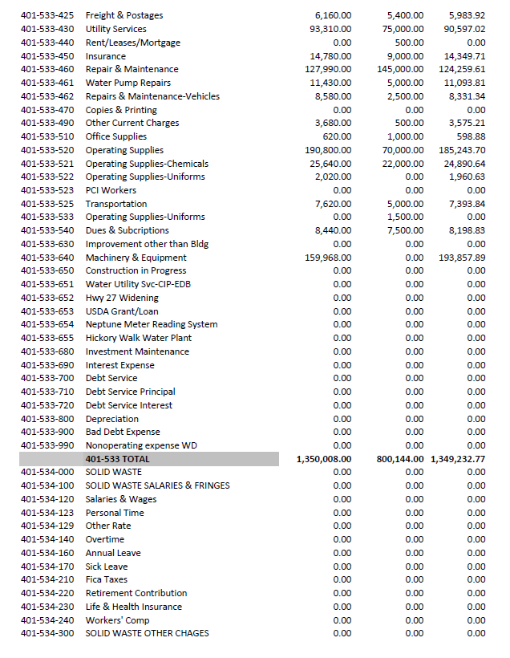
EXHIBIT A
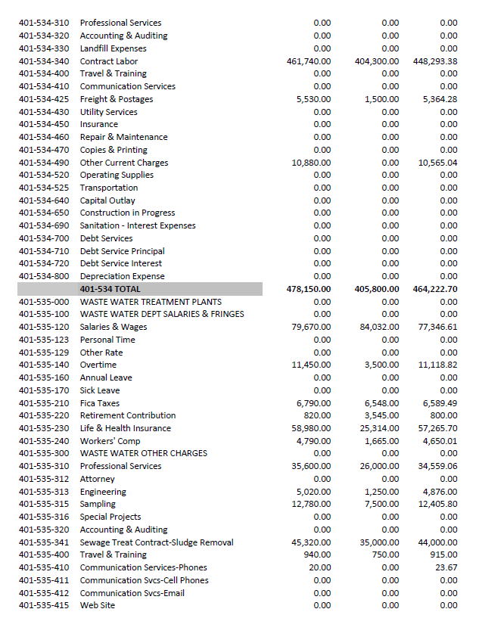
EXHIBIT A
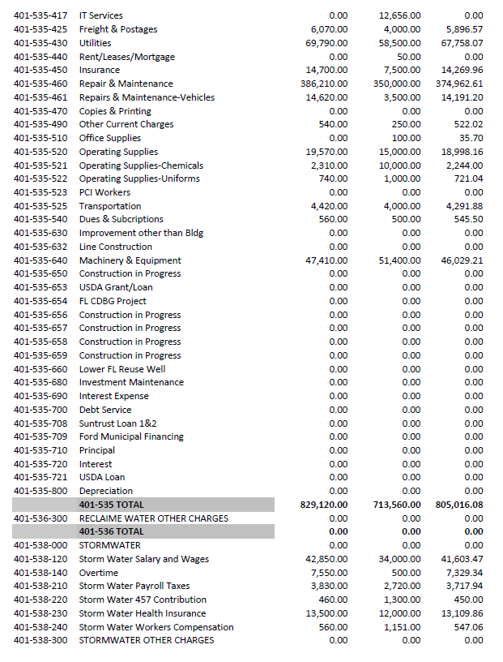
EXHIBIT A
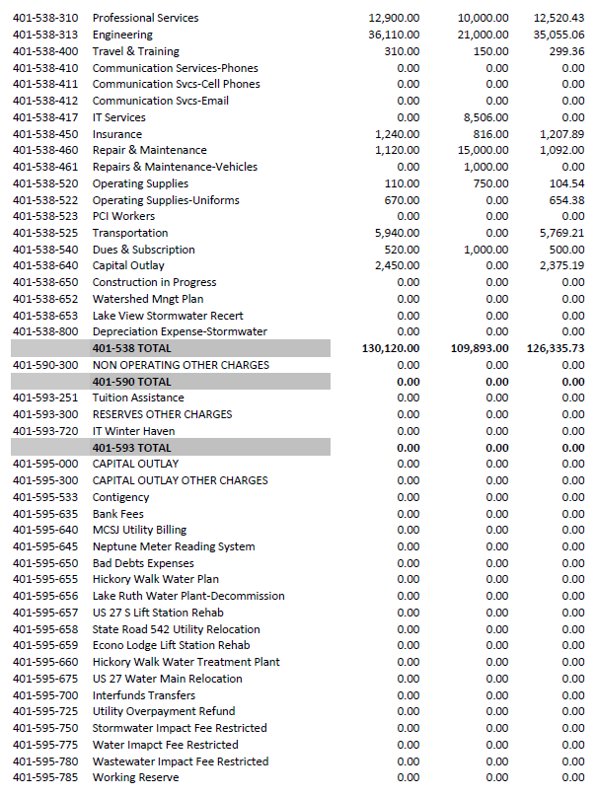
EXHIBIT A
