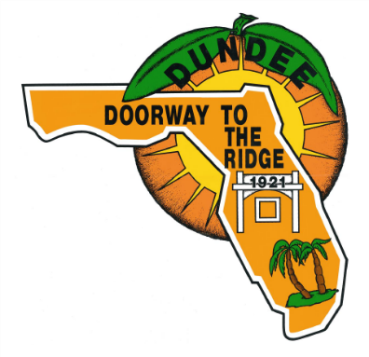
VISIONING COMMITTEE MEETING Minutes
September 20, 2024 at 12:00 PM
DUNDEE COMMUNITY CENTER – 603 lAKE mARIE bLVD., Dundee, FL 33838
Phone: 863-438-8330 | www.TownofDundee.com
WelcomE AND INTRODUCTIONS made by Lorraine Peterson, Assistant Town Manager
iN ATTENDANCE

Tandra Davis, Town Manager
Lorraine Peterson, Assistant Town Manager
Commissioner Mary Richardson
Seth Claytor, Assistant Town Attorney
Lita O’Neill, Town Clerk
Vermalyn Williams, Code Enforcement Officer
Matt Jones, Parks and Recreation Director
John Vice, Public Works Director
Marisa Barmby, Central Florida Regional Planning Council
Robert A. Stevens, RAS and Associates
Andrew Stevens, RAS and Associates
Matthew Ivie, Ayres Associates
Diego Guerra, Ayres Associates
Matt Ashby, Ayres Associates
Jeffrey Siewert, Ayres Associates
Tammy Vrana, Vrana Consulting, Inc.
Merissa Green, Visioning Committee Member
Jackie Nichols, Visioning Committee Member
Clark Tallman, Visioning Committee Member
Jennifer Nguyen, Visioning Committee Member
Alethea Pugh, Visioning Committee Member
Rhonda Sara, Visioning Committee Member
Waymon Meadows, Resident
Burnie Nichols, Resident
Barb Tallman, Resident
James Fenley, Resident
Carolyn Fenley, Resident
Roberto Melendez, Resident

MISSION AND VISION
Town Clerk, Lita O’Neill presented a PowerPoint presentation highlighting the mission, vision, goals, and pillars of neighboring municipalities in Polk County. The main question for the visioning process is “Who are we, Dundee?”
HISTORY OF DUNDEE
Marisa Barmby with the Central Florida Regional Planning Council presented a PowerPoint presentation with many key details about the history of Dundee. Ms. Barmby provided the Town Clerk with an electronic copy of the presentation.
[The presentation may be accessed here - ..\2024 Agendas\09.20.2024\20240920 Dundee Visioning Meeting presentation 092024.pptx]

CONSULTANT PRESENTATION – AYRES ASSOCIATES
Staff from Ayres Associates presented a PowerPoint presentation about the company and the processes used for community engagement and setting goals for visioning, as well as provided examples of projects completed around Florida, including 3D renderings for Crescent City, the South Florida Avenue Corridor in Lakeland, Brooksville Community Park Planning, and developing an Historic Preservation Plan for the City of Saint Cloud.
Ayres consultants reviewed the community engagement process and branding. “We need a vision that gives you goosebumps.” They also noted that creating the story first leads into the implementation.
Ayres staff provided the Town Clerk with an electronic copy of the PowerPoint presentation.
[Access the PowerPoint presentation here - ..\2024 Agendas\09.20.2024\20240920 Ayres Dundee Visioning Presentation_Sep 20 MA.pptx]
CONSULTANT PRESENTATION – ROBERT A. STEVENS and ASSOCIATES
“The City of Winter Haven is a 20-year overnight success.” RAS and Associates highlighted expertise in GIS, mapping, and data analysis that may be used to assist Dundee in identifying where we are and where we are going. The main economic driver has been citrus, but change is underway.
[The RAS Presentation is here - ..\2024 Agendas\09.20.2024\20240920 RSA_Town of Dundee Vision Board.pptx]
STAFF RECAP
Due to time constraints, staff did not provide a staff recap, but Town Manager Davis noted that an email with all the presentations will be sent to attendees.
ANNOUNCEMENTS AND QUESTIONS
Discussion ensued about the first official meeting of the Visioning Committee and when it would take place. The general consensus was that Fridays work well. The Town Clerk will send a poll out to determine the best date and time for the meeting.
Respectfully submitted,
Lita O’Neill
Lita O’Neill, Town Clerk

Date Approved: __________________
PUBLIC NOTICE: Please be advised that if you desire to appeal from any decisions made as a result of the above hearing or meeting, you will need a record of the proceedings and in some cases, a verbatim record is required. You must make your own arrangements to produce this record. (Florida statute 286.0105) If you are a person with disability who needs any accommodations in order to participate in this proceeding, you are entitled, at no cost to you, to the provision of certain assistance. Please contact the town clerk’s office at 202 east main street, Dundee, Florida 33838 or phone (863) 438-8330 within 2 working days of your receipt of this meeting notification; if you are hearing or voice impaired, call 1-800-955-8771.

