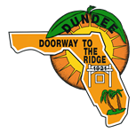
TOWN OF DUNDEE
NOTICE OF INTENT
REJECTION OF ALL BIDS

June 13, 2022
RFP 22-04 NEW 40’ X 40’ STEEL BUILDING FOR UTILITIES DEPARTMENT
Notification that all bids received on the above-referenced RFP have been rejected on the basis that all bids exceeded the project estimated budgeted amount.
Town Staff thanks all who took the time to participate in this RFP and submitted a bid for this service. We intend to re-bid this project in the future after reevaluating accordingly.

