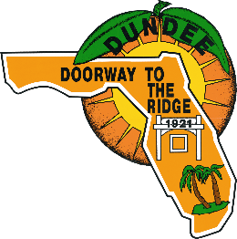
TABULATION RECORD/INTENT TO AWARD DOCUMENTATION
∙ 202 E. Main Street, Dundee, FL 33838 ∙ Phone: (863)438-8330 ∙
Web: www.TownofDundee.com
 | Project Number: |  |  | 24-04
 | Project Name: |  |  | RFP 24-04 Dundee Community Center Renovations
 | Type of BID: |  |  | Request for Proposal
 | Purchasing Representative: |  |  | John Vice
 | Due Date: |  |  | 3/20/2024 |  |  |  |  |  |  | Location: | 202 E Main Street  Dundee FL 33838
 | Opening Date: |  |  | 3/21/2024
 |  | CONTRACTOR | CITY, STATE |  | BASE BID | OPTIONAL BID 1 |  | OPTIONAL BID 2 |  | TOTAL COST BASE BID PLUS OPTIONAL  BIDS 1 AND 2 |  |  | ADDENDA ACKNOWLEDGED |  |  |  | INTENT TO AWARD
 |  |  |  |  |  |  |  |  |  |  |  |  | ADD 1 | ADD 2 | ADD 3
1 |  | JCR Construction and Services, LLC | Lakeland, FL |  | 95285.90 | 1700.00 |  |  |  | 96,985.90 |  |  |  |  |  |  | Yes
2 |  | SEMCO Construction, INC | Bartow, FL |  | 70,803.71 | 6700.00 |  |  |  | 77,503.71 |  |  |  |  |  |  | No
3
4
5
6
7
8
9
10
11
12

